**Introduction to UNIX**

**LAB # 01**

** Fall 2019**

**Spring 2021**

**CSE204L Operating System**

Submitted by: **Ashfaq Ahmad**

Registration No: **19PWCSE1795**

Class Section: **B**

“On my honor, as student of University of Engineering and Technology, I have neither given nor received unauthorized assistance on this academic work.”

Student Signature: ______________

Submitted to:

**Engr. Mian Ibad Ali Shah**

April 25 , 2021

**Department of Computer Systems Engineering**

**University of Engineering and Technology, Peshawar**

**UNIX:**

* UNIX is an operating system which was first developed in the 1960s, and has been under constant development ever since.
* By operating system, we mean the suite of programs which make the computer work. It is a stable, multi-user, multi-tasking system for servers, desktops and laptops.
* UNIX systems also have a graphical user interface (GUI) similar to Microsoft Windows which provides an easy to use environment. However, knowledge of UNIX is required for operations which aren't covered by a graphical program, or for when there is no windows interface available, for example, in a telnet session.
* Ubuntu is a complete Linux operating system, freely available with both community and professional support.

There are many different versions of UNIX, although they share common similarities. The most popular varieties of UNIX are **Sun Solaris, GNU/Linux, and MacOS X.**

**The UNIX Operating system:**

The UNIX operating system is made up of three parts; the kernel, the shell and the programs.

### The kernel

The kernel of UNIX is the hub of the operating system: it allocates time and memory to programs and handles the file store and communications in response to system calls.

### The shell

The shell acts as an interface between the user and the kernel. When a user logs in, the login program checks the username and password, and then starts another program called the shell. The shell is a command line interpreter (CLI). lIt interprets the commands the user types in and arranges for them to be carried out. The commands are themselves programs: when they terminate, the shell gives the user another prompt (% on our systems).

**The Directory Structure:**

All the files are grouped together in the directory structure. The file-system is arranged in a hierarchical structure, like an inverted tree. The top of the hierarchy is traditionally called **root** (written as a slash / )

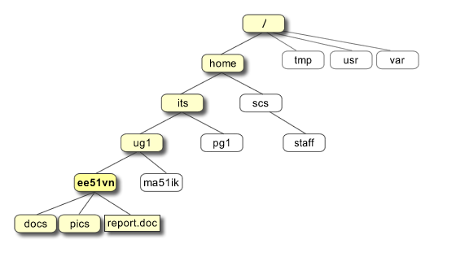

In the diagram above, we see that the home directory of the undergraduate student **"ee51vn"** contains two sub-directories (**docs** and **pics**) and a file called **report.doc**.

The full path to the file **report.doc** is **"/home/its/ug1/ee51vn/report.doc"**

**Different Commands**

**Pwd command:**

Pwd stand for present working directory:

**Output:**

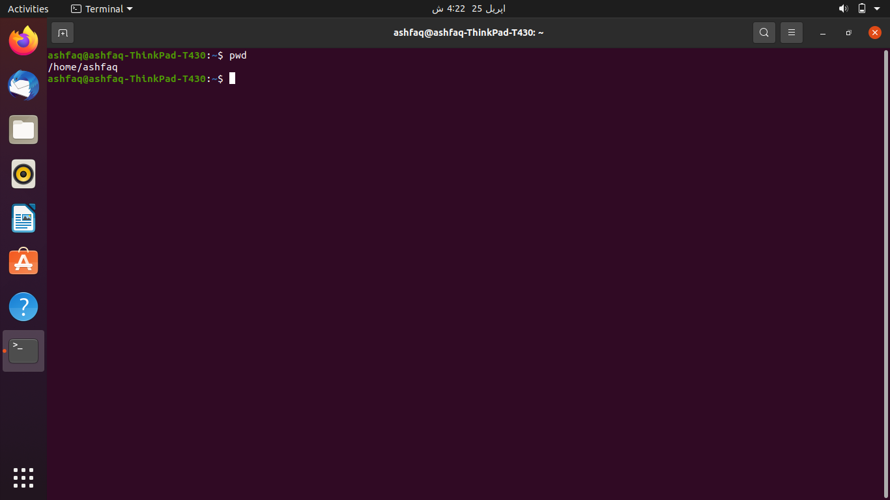

**Ls command:**

Ls command is used to show list:

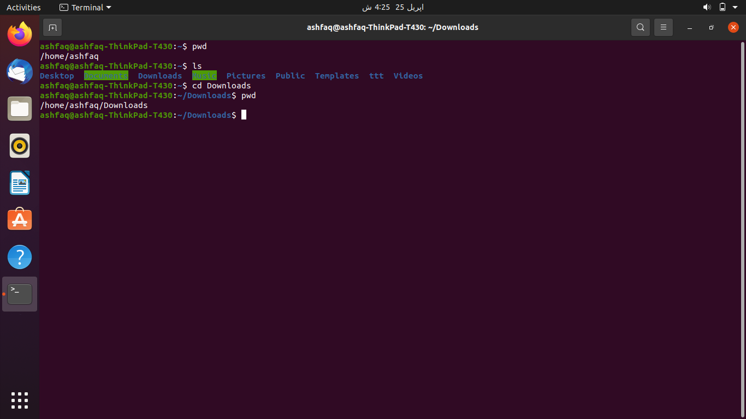

**Cd command:**

Cd command is used to change directory:

Output:



**Mkdir command:**

Mkdir command is used for making directory:

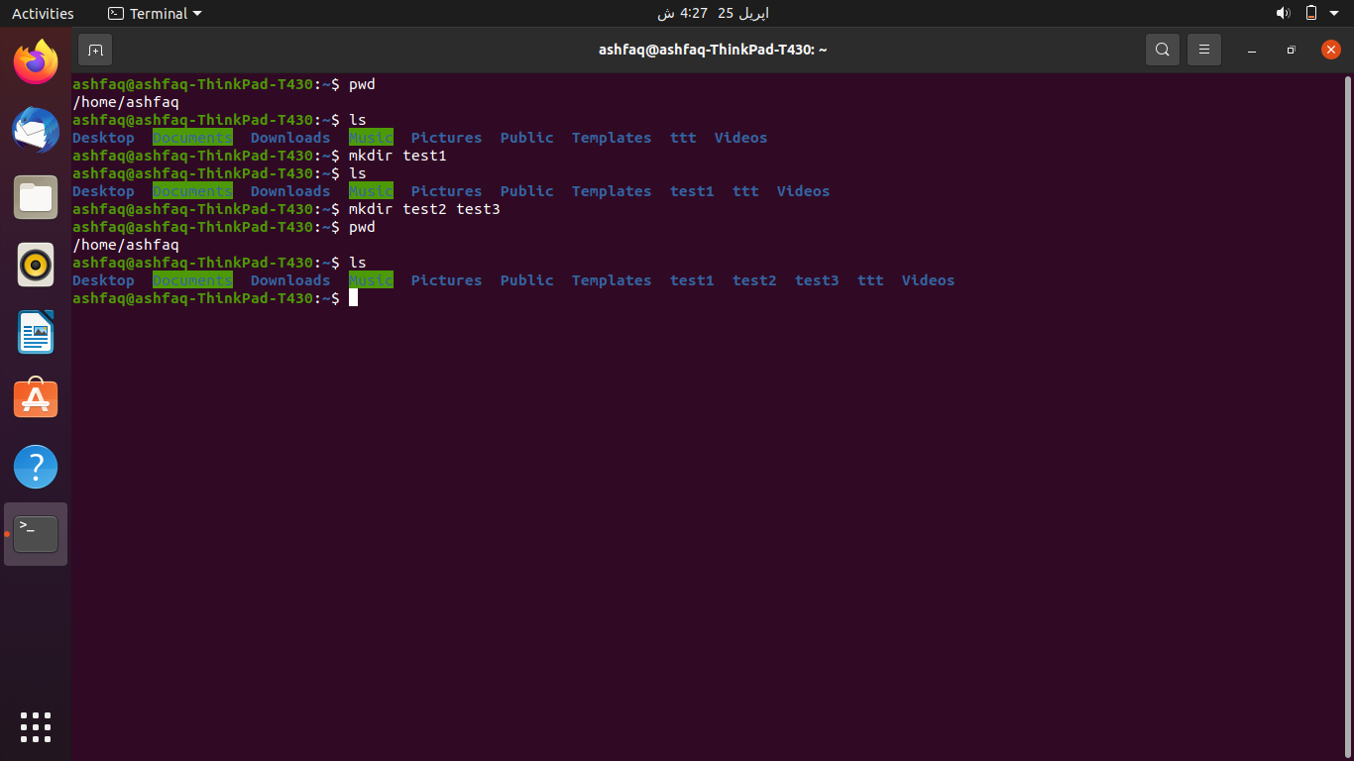

While **RMdir** is used for removing directory:

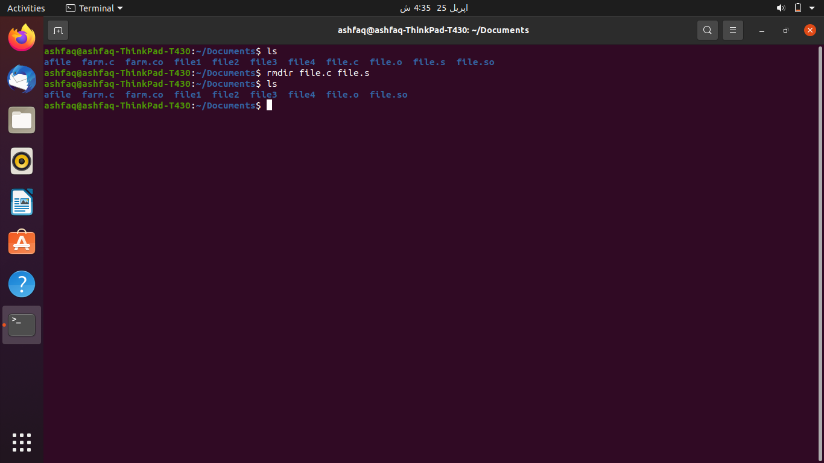

**Whoami command:**

Output:

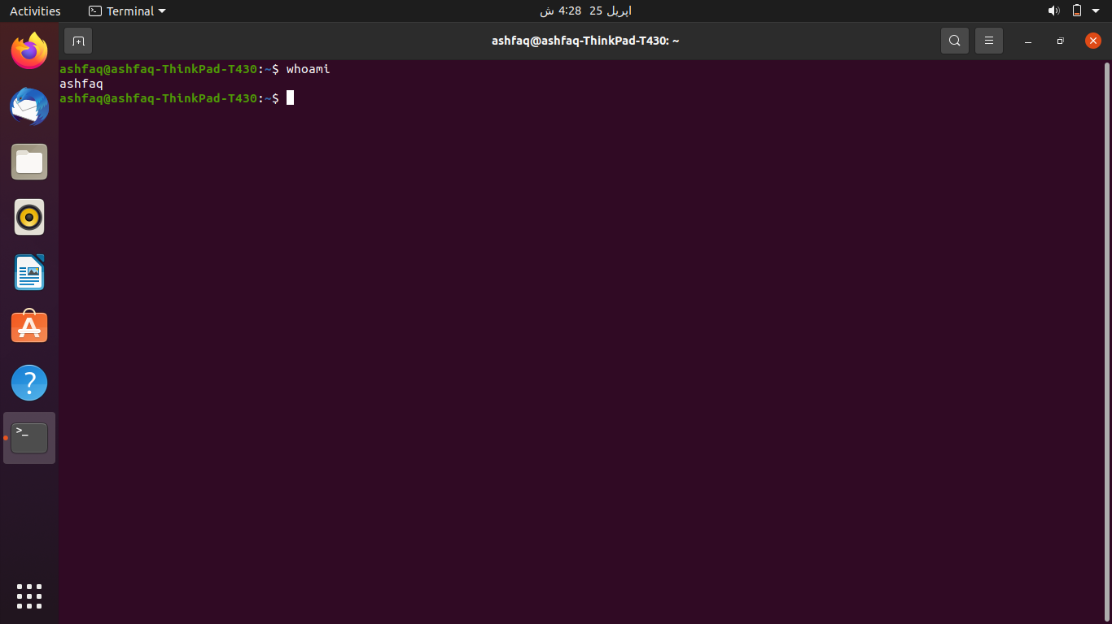

**History command:**

Output:

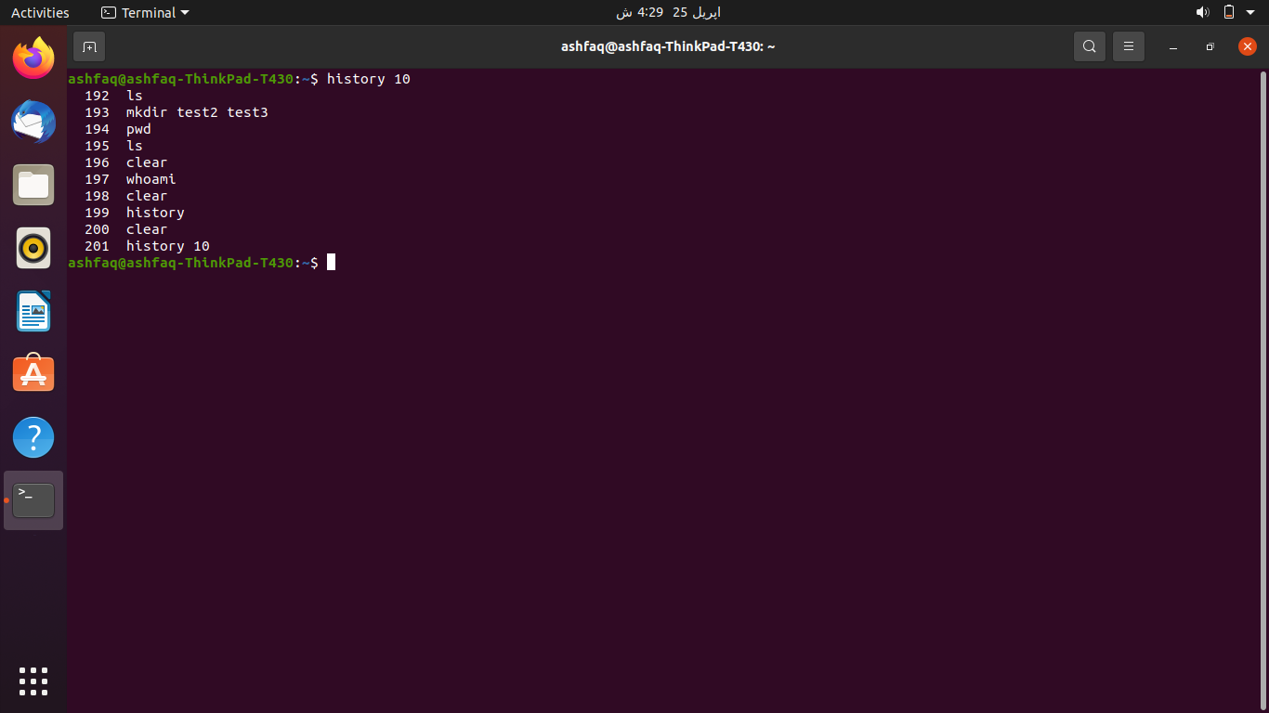

**Ls –l command:**

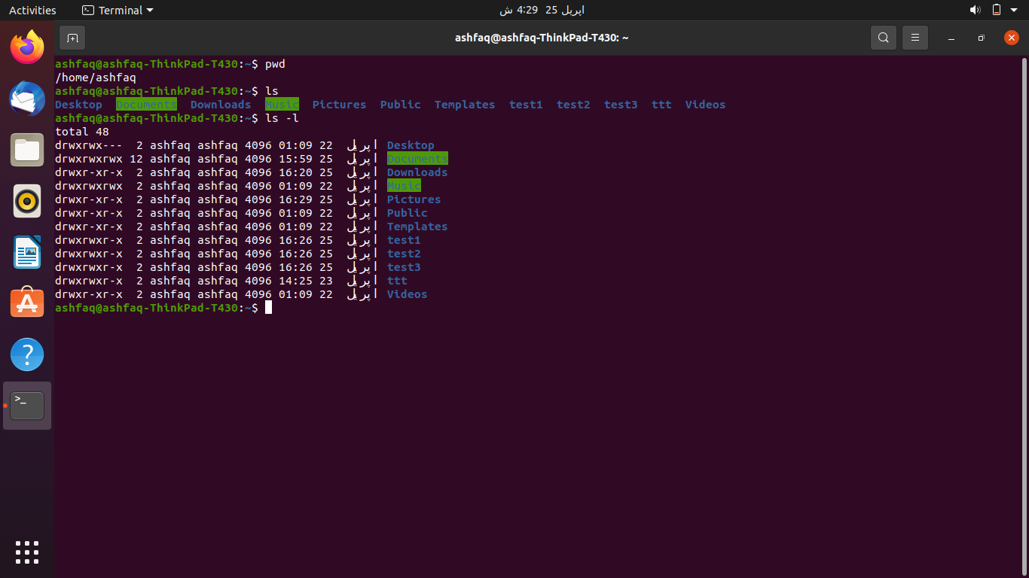

**Question:**

1. Listing of files.

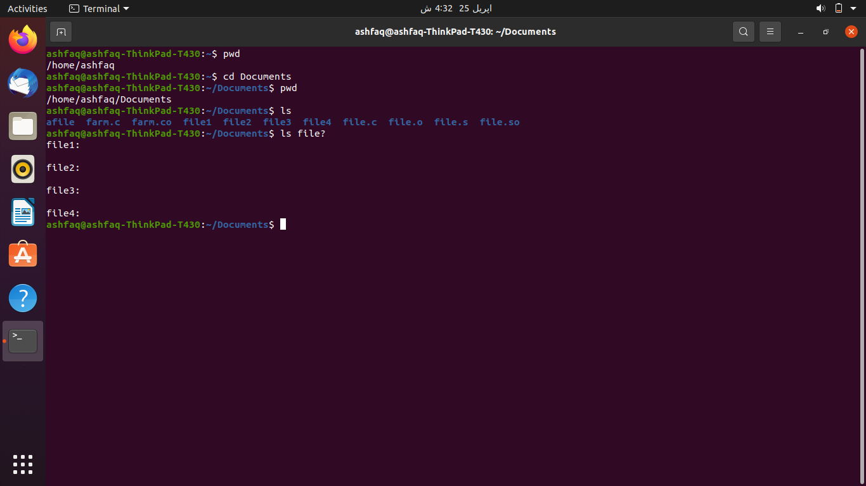

1. Removing a file.



1. Listing the files bagaining with “f”.

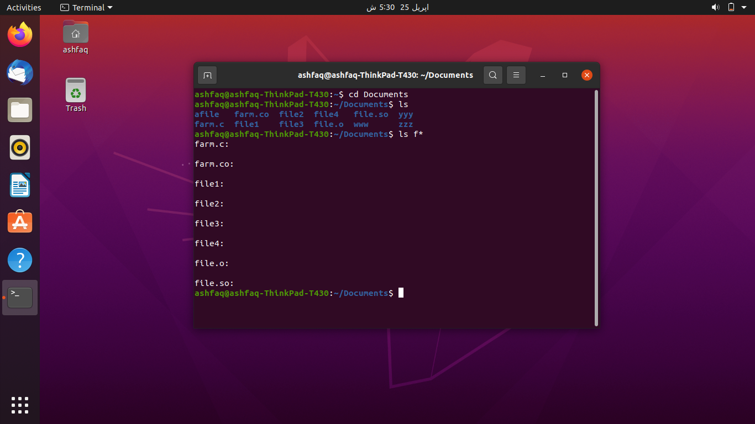

**THE END**